**Bellringer:** Endomembrane System

AP Biology

Examine the diagram of the endomembrane system below.

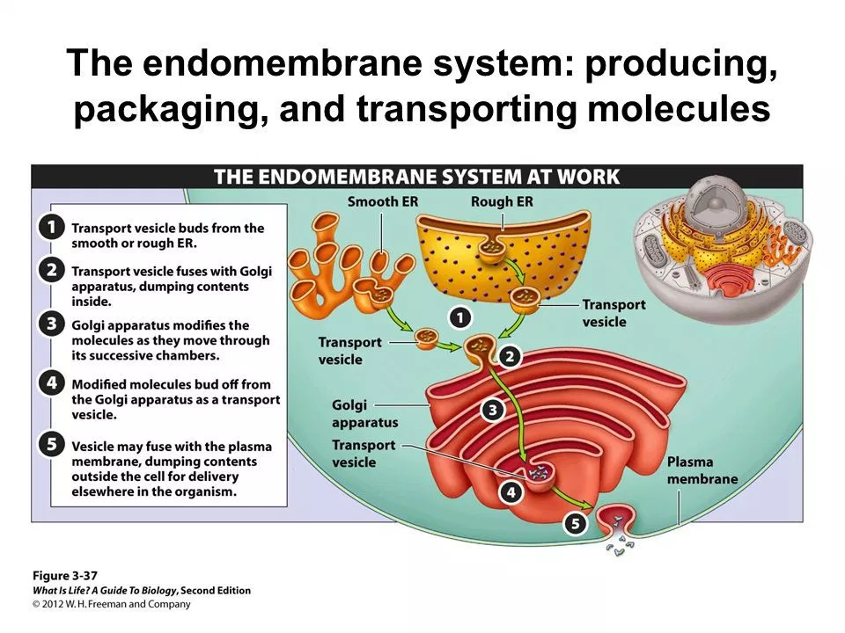

Name two advantages this system could provide for a cell.

How could this system help the eukaryotic cell increase its surface area and volume ratio?

**Bellringer:** Endomembrane System

AP Biology

Examine the diagram of the endomembrane system below.



Name two advantages this system could provide for a cell.

How could this system help the eukaryotic cell increase its surface area and volume ratio?